Witmart.com provides lots of opportunity for someone to earn some money. They now have a new feature that allows you to earn money by promoting new users to register and bid for a job. By becoming a Promoter, you will help Employers by bringing qualified bids to the job. The best part is that you get paid!

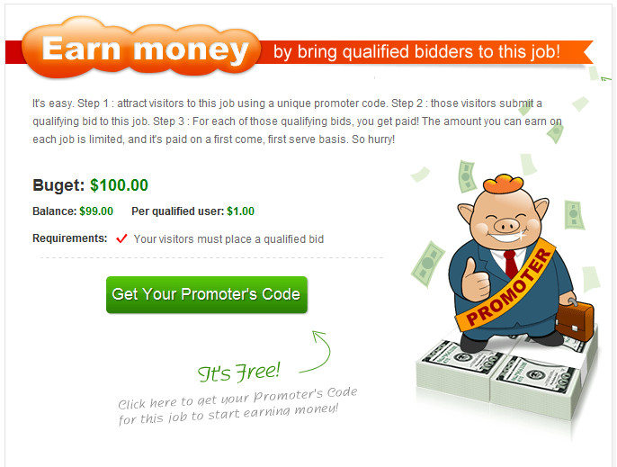

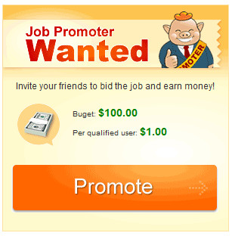
You must first apply for a license to become a Promoter. With a Promoter license, you will be able to apply to any job that has enabled the Promoter Function. Fill out an application including your use of and access to social media sites. You are expected to be truthful and honest about all of the information you provide. Once you’ve submitted your application, Witmart will evaluate whether or not you are qualified based on your answers on your application. If you are qualified, you will be contacted by phone to verify your identity. After your identity is confirmed, you will be granted a Promoter’s license.
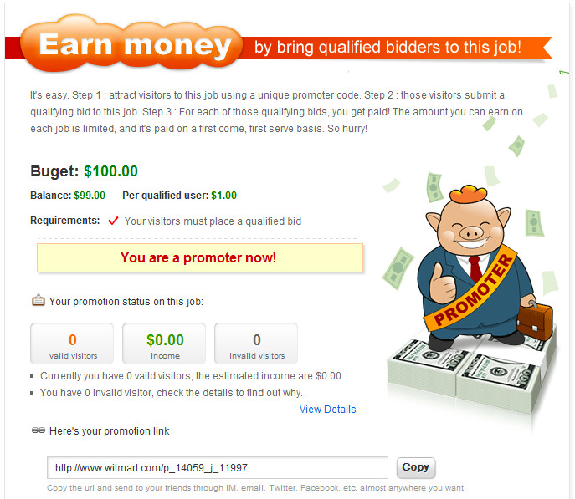

Now that you are a Promoter, you can apply for any job that has allowed the Promoter feature. Simply click the “Promote” button and you will receive a unique link to send to others. This link will be used to track the traffic that you bring in. It will measure whether or not the bids or visitors are qualified. The Employer decides how much to pay you per qualified visitor. Of course, the Employer will most likely set a limit on how much he/she is willing to pay total.


The best way to invite people to register and bid for the job is to make use of social media sites like Twitter, Facebook, blogs, etc. When you make a post to one of these sites, be sure to include your unique link—otherwise it won’t be counted! Be sure to think about who would be best to complete the job that you are promoting, and fully explain what it is that you are doing. You can also use your email to send friends the link.

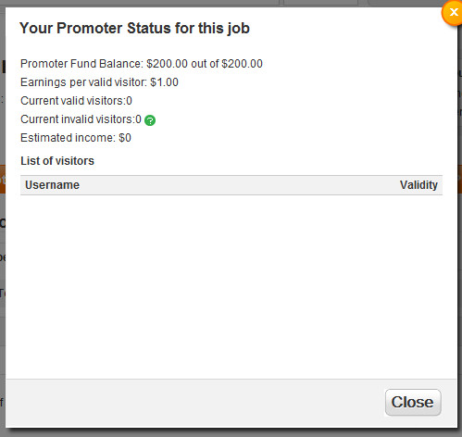
Qualified users are defined as newly registered users who have submitted a bid to the job you are promoting. You must be fully aware of the importance of not violating the User Agreement Policy when it comes to the Promoter function. Witmart.com lists the following as violations to the Promoter function:
- An unreasonable number of users from the same or similar IP address;
- Users with junk email addresses, names and user names.

If you violate the policy, your Promoter’s license could be revoked. You will be held responsible for any unreasonable or unreliable actions taken on your part.

Becoming a Promoter is easy! Earning money by promoting is easy! Take this opportunity to earn more money today!

