Haven’t found a job that you would like to do? No worries. Even if you have not found any job that matches your skills, you can still earn money by becoming a Job Promoter. This article will bring you through four simple steps that can help you earn some money as a Job Promoter.

Summary

For any job that is posted, there may be a Promote button on the right side of the page (see figure 1). If you think you know someone who can do this job well, you can click on the button to promote this job. After that, you need to apply to become a Promoter by submitting an online application form. Once you become an official Promoter, you will get a unique link for each job you want to promote. Send this link to as many friends as you can. Once they click on the link and submit a qualified bid for the job, you earn money.

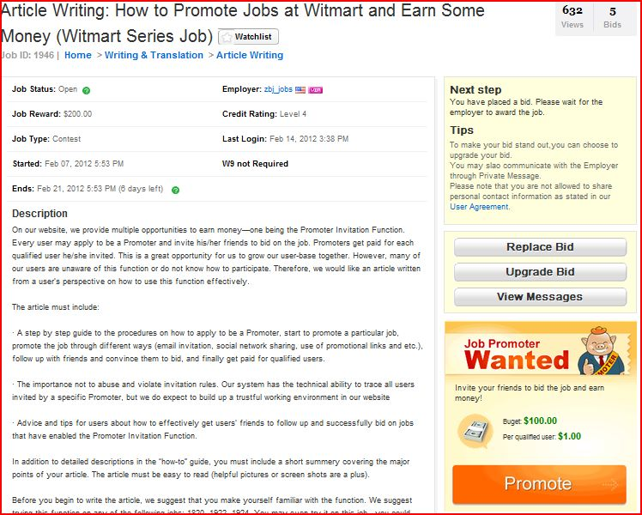
Figure 1

Step One: Become A Promoter

Just like any real estate agent or sales agent must first become qualified before they can start selling, so our Job Promoters also must become qualified promoters before they start promoting. To become a Promoter, you have to be a registered Witmart user. For how to register a Witmart account, please see http://www.witmart.com/help/.

After you click on the Promote button, you will be directed to a page that asks you to sign up as a Promoter first (see figure 2).

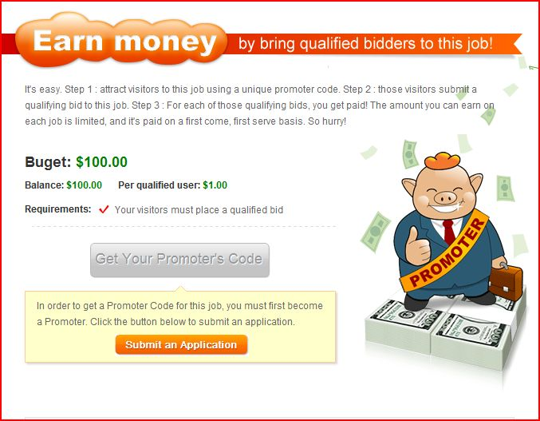 Figure 2

Simply click on the Submit an Application button and you will see an application form (see figure 3). One good thing about this application process is that the application form is really short, consisting of only 9 questions. One important thing to note is that you must provide your authentic phone number, as this will be used to contact you if you are a possible qualified Promoter. However, be rest assured that all personal information provided to Witmart is confidential and will not be released to the public.

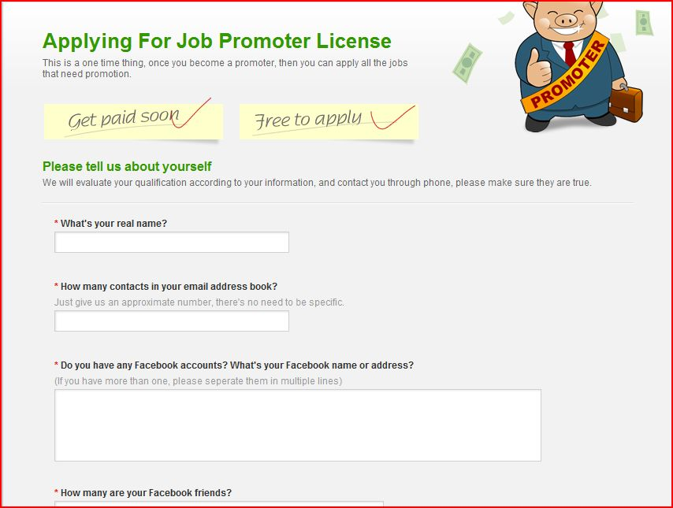
Figure 3

It will take about 3 minutes to fill in the application form. After that, you will see a page acknowledging your submission (see figure 4).
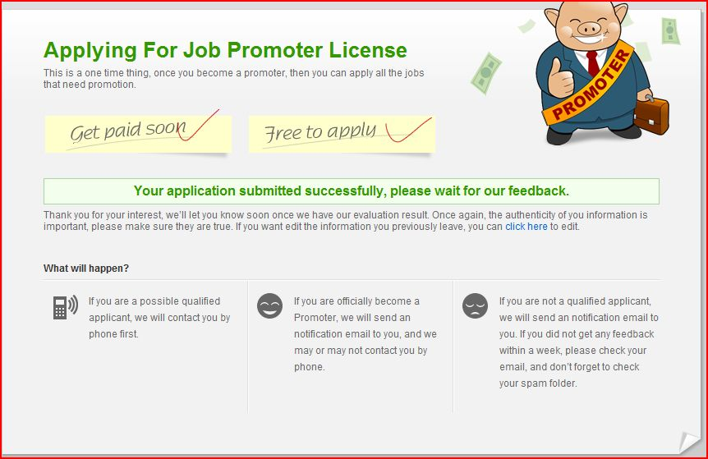
Figure 4
After submission of application form, you will be contacted by phone if you are a possible qualified Promoter. Once you become an official Promoter, a notification email will be sent to you. If you are unable to become a qualified Promoter, an email will also be sent to you. But please don’t be discouraged. There are plenty of opportunities in the future.

Step Two: Get the Link

After you have become an official Promoter, for each job that you would like to promote, you will get a unique and simple promoter link. This link has your specific promoter link embedded in it, so that once your friends click on the link to view the job, we would know that you are the one who has promoted the job.

Step Three: Promote the Job

Just getting the link does not mean your job is done. The whole point of getting a promoter link is so that you could post the link on your own website, blog, MySpace etc. You can also send this link via email to your contacts, or to your friends on Facebook, Twitter, or any other social networking sites. The more links you send, the better the chance of someone clicking on it and viewing the job.

Step Four: Get Paid $$$

Once your friends have viewed the job and submitted a qualified bid for it, you earn money. For each qualified bid submitted, you earn $1. The more qualified bids, the more money you earn. One thing to note is that for your friends to submit a qualified bid, they have to become a registered Witmart user.

Notes

There are a few things that you need to take note of while working as a Promoter.

1. The unique link sent to you will expire when the job has entered Awarding status.

2. The purpose of this Promoter Invitation Function is to get more users to bid for a job, hence it does not help if one user submits multiple bids using different account names or you set up different accounts to bid for a job in order to earn more Promoter fees. We believe that our users have the integrity not to abuse and violate the invitation rules.

3. Promoter rules may differ slightly for different jobs, so please check the rules first before you start promoting.

Tips on How to Earn More $$$ As A Promoter

1. To be able to earn $$ as a Promoter, you have to be a qualified Promoter in the first place. One suggestion is that before the application process, you should already have social networking sites accounts, such as Facebook, Twitter, or Google+. Besides, check to see how many contacts you have on these sites. The more contacts, the more valuable you will be as a Promoter.

2. Sending out the link to many friends may not guarantee that you will get $$, unless they click on the link and submit a qualified bid. To get your friends to submit a bid, you should not just simply send them the link. For example, you can add a message if you are sending them the link via email: Hey, I found this job on Witmart. I think you can definitely do it and earn some money! Just click on the link and submit a bid:D.

Sounds simple enough? So what are you waiting for? Become a Promoter now! (insert link to application page here)

Author: tvxqjuly

