喜来游https://www.tripleasure.com fill out info like this. Choose 1) date {calendar see https://www.lulutrip.com}, 2) pick up seclude, 3) room-adult-child {after fill our 1-3, it will show the end of date and a calculation table to a customer see calculator https://www.lulutrip.com}, 4) fill out name who will go to a trip, 5) flight, 6) remark optional. Above 1-4 is required, 5-6 is optional can be fill out later.
- Choose calendar (the departure date) like powerful calendar as https://www.lulutrip.com
- Pick up seclude, if other than a regular pick up time. It will calculate additional charge see http://www.usitrip.com powerful calculator.
- Choose how many rooms? How many people adult and children? After fill out 1-3, it will show a total like http://www.usitrip.com powerful calculator.
- SEO http://www.toursforfun.com/
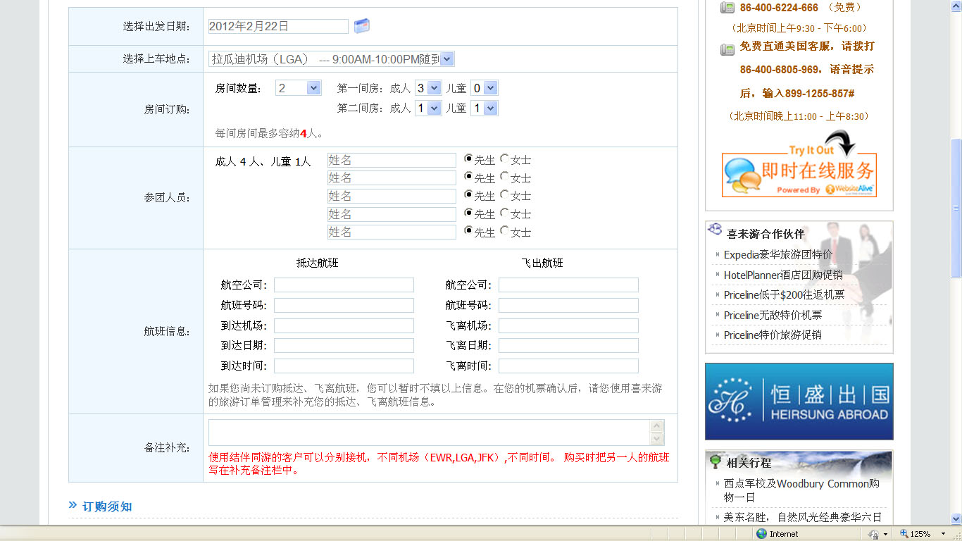

After fill everything out; click add-to-cart, go to shopping_cart page we can edit, remove, continue shopping or submit to go payment processing fill credit card info.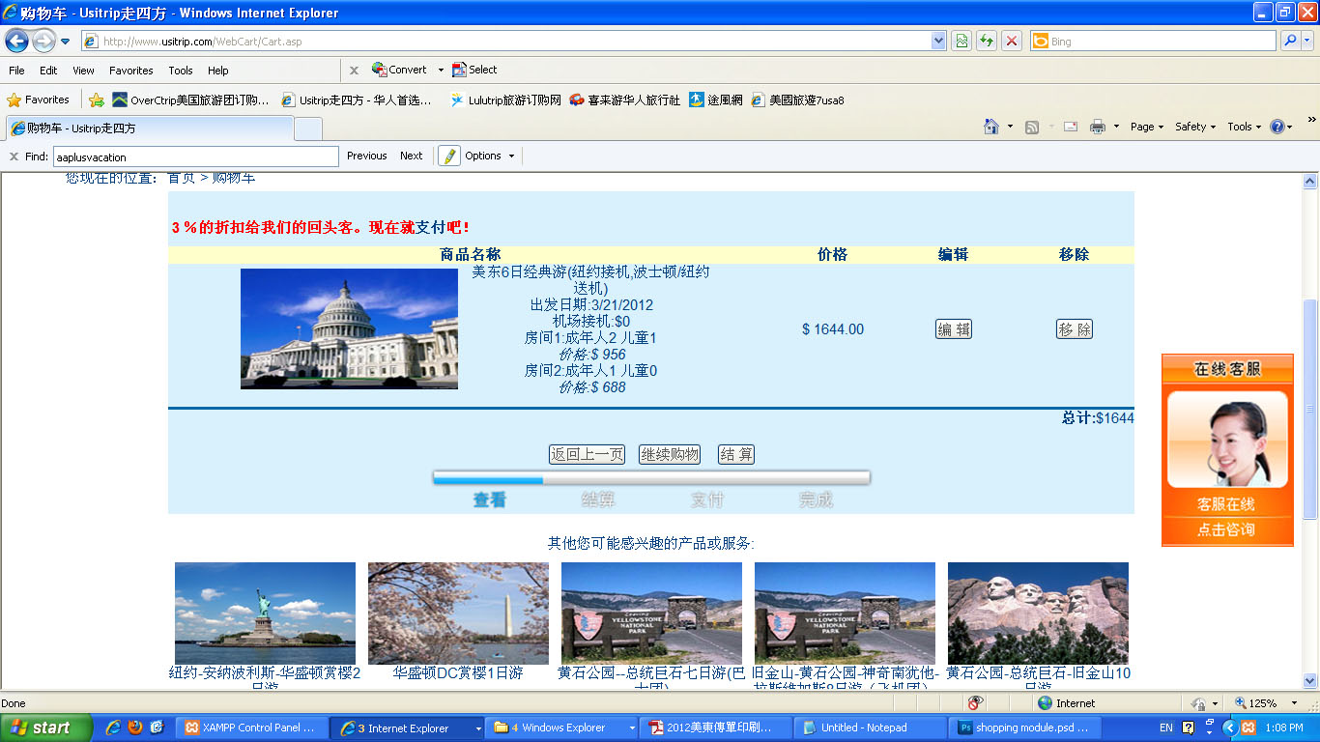
Click 結算 then go to a page to fill out credit card info.
走四方http://www.usitrip.com powerful calculate after choose a date it will show end date and price table to customer.
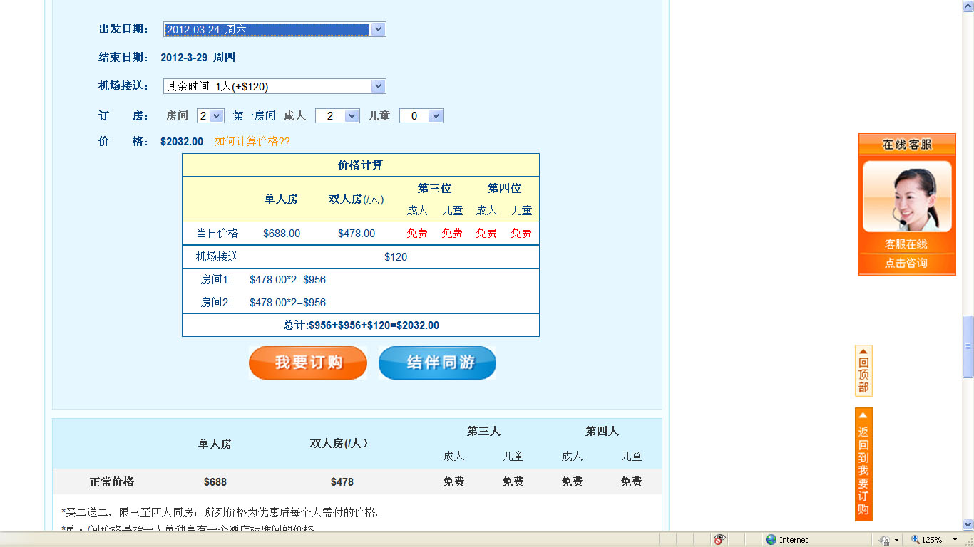
路路旅遊https://www.lulutrip.com powerful calendar, only the day highlighted can choose for a trip, if the trip sold out. The date will turn red.
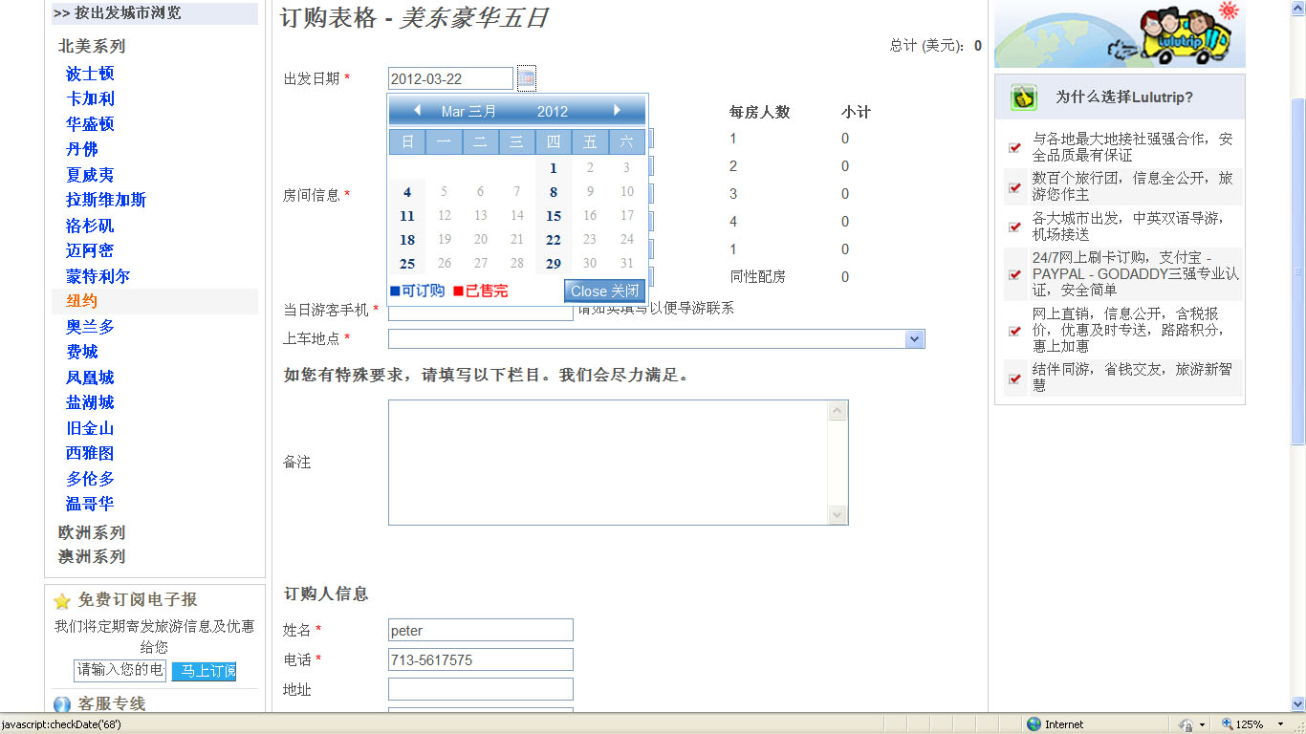

Shopping cart search http://www.toursforfun.com/ when click出發地, 目的地, 天數, it will pop up a list to let me choose.